Gerardo Ponce, Osteopathic Manual Practitioner, 724 Adelaide Street North, London, ON.

OSTEOPATHY INFORMED CONSENT
Osteopathy is a manual therapy that is based on holistic philosophy as seen the body as a whole unit, and that all systems and structures are interrelated and that one can affect the other and vice versa.
Osteopathy practice is also based on clinical findings from assessment of imbalances of the soft tissues, joints, bones, cranial bones, tendons, ligaments, visceral organs, circulatory, nervous, lymphatic systems of the body and the treatments and prevention to maintain optimal balance in the body
As in any manual therapy, there are some side effects or unwanted results that are temporary and that will subside in short time. Some of the most commons side effects are soreness, headaches, small bruises if you are prone to get bruises, feeling tired, increase pain and inflammation in some cases. symptoms sometimes may seen to worsen before they get better.
The Osteopathic manual practitioner will farther explain to me the procedures of assessment and treatments. In general, Osteopathic techniques are light- gentle manipulations in which includes mobilizations of joints, tendons, ligaments, cranial bones ,nerves , vertebraes, visceral organs, soft tissues, and stretches depending on the condition presented. I am welcome to ask any questions at any time to clarify procedures.
Fees include HST. for initial assessment/treatment is $146.90/ follow up treatments are $158.20 per 60 min/ $124.30 per 45min/ $90.40 per 30 min sessions/. THERE IS A FEE OF $65.00 FOR MISSING, CHANGING OR CANCELLING APPOINTMENTS IN LESS THAN 24 HOURS.
I,_____________________________________________ have read and give consent for the Osteopathic practitioner to do an assessment and treatment on me. I understand that this consent does not imply consent for subsequent visits and that the practitioner will ask for consent to treatment verbally for each subsequent visits. I know that I can withdraw consent to treatments at any time

Signature Client/parent____________________________________Date_________________________

OSTEOPATHY HEALTH HISTORY FORM

First Name Surname Date
Address:
Home phone Cell phone
Email Address:

Date of Birth:
Emergency contact: Phone#

Family Doctor: Phone#

General Information
Occupation_________________________________________________________
Do you wear orthotic shoes? ___________________________________________
Have you had any X-RAYS. MRI, CT SCANS? ___________________________
Result if any________________________________________________________

Chief Complaint and Duration:

Medication taken:

PAST AND PRESENT MEDICAL HISTORY

- Osteoporosis | - Immune disorder | - Glaucoma
- Osteoarthritis | - Insomnia | - Hepatitis
- Gout | - Tuberculosis | - Thyroid disease
- High cholesterol | - Scoliosis | - Anemia
- High blood pressure/Heart disease | - TMJ/Orthodontic Issues | - Bleeding /Haemophilia
- Headaches/migraines | - Mental health issues | - Diabetes
- Ulcers | - Irritable bowel syndrome/crohn's disease | - Heart attack/ Stroke/Aneurism
- Urinary infection | - Blood clots | - Seizures/Epilepsy
- Eczema/hives | - liver disease | - Asthma/breathing issues
- Pneumonia | - Depression | - Gall/Kidney stones
- Anxiety | - Menopause | - Cancer
- For Women:Pregnant? | - Ringing in the ears | - Sinusitis
- Dizziness/vertigo | - Digestive problems | - Painful/frequent urination
- HIV/AIDS | - Allergies | - Skin/herpes/contagious disease
- Heartburn/acid reflux | - For Women: PMS/ Menstrual irregularities | - Hernias
- Diarrhea/Constipation | - For Women: Gynaecology issues/IUD | - Sleep apnea

Surgeries/Fractures in the past?___________________________________________________
Other medical conditions not mentioned above?______________________________________
Knee/hip replacement/metal plates or metal screws in the body?_________________________
Any type of accidents in the past?__________________________________________________
MUSCULOSKELETAL CONDITIONS:
Degenerative disc/herniation | Numbness/tingling in arms/hands
Knee/Hip /Ankle pain | Carpal tunnel
Shoulder/neck pain | Low back/sciatic pain
Numbness/tingling in legs/feet | Pelvic/tail bone pain

PLEASE MARK AREAS WHERE YOU HAVE PAIN
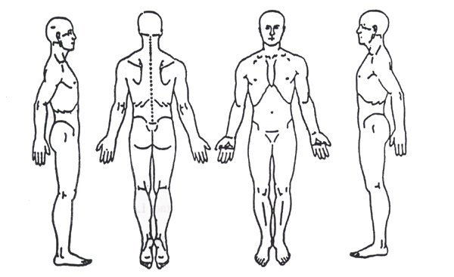

Clinical notes:

